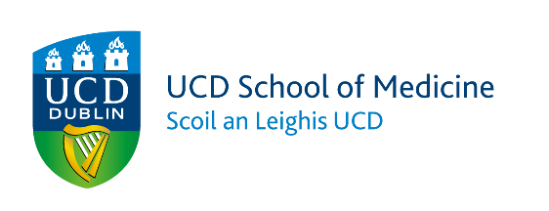

Radiography & Diagnostic Imaging
UCD School of Medicine

Pre-course requirement for UCD MSc Medical Imaging Programme

https://www.ucd.ie/medicine/studywithus/graduate/radiographydiagnosticimaging/specialistprogrammes/mastersinmedicalimaging/
Applicant Name
Contact email

In order to fulfill the pre-course requirements for the MSc Medical Imaging Programme in UCD, students are required to have completed the following:
- Personal Statement
- Signature of sponsor / person or organisation paying the fees (if not self-funded)
Course Administrator: Radiography & Diagnostic Imaging Administration Office,
Graduate Taught Programmes
Room A222,
School of Medicine,
University College Dublin,
Belfield,
Dublin 4.
Email: graduate.imaging@ucd.ie

ALL SECTIONS OF THIS DOCUMENT MUST BE TYPED APART FROM THE PAGE WHICH REQUIRES SIGNATURES. PLEASE ENSURE YOUR EMPLOYER / FINANCIAL SPONSOR HAS READ OVER THIS DOCUMENT AND AGREES TO ALL TERMS BEFORE SIGNING.
Programme X677 | September Offering  Full Time
Programme X674 | September Offering  Part Time
Programme X675 | January Offering  Part Time

Applicants that require a visa to travel MUST apply for the full-time offering otherwise they may not be granted a study visa. Applicants are required to organise their own visa and travel arrangements.

Successful candidates will be provided with a list of suitable modules, which will be discussed on an individual basis. For more information on the available MSc modules, please search here.

*Dissertation (Medical Imaging)  Module Code RDGY41130  Blended Learning | Year-long (12 months)  30 credits
All students must undertake a module in research methods in either Autumn or Spring Trimester of Year 1.
*All students must undertake Dissertation (Medical Imaging) module in Year 2.

Students can take a maximum of 40 ECTS per Trimester.
Total credits for the programme are 90 ECTS.

Please use the space below to reflect on your experience in the Diagnostic Imaging Department. You should provide a brief summary of why you wish to study to MSc level, what you hope to achieve by completing the course and any problems/difficulties you may encounter during your studies. Maximum 250 words.

Please provide email contact details of two referees who can comment on your suitability for the course, motivation, and ability to study at Masters level.
Referee 1
Email address: …………………………………………………………
Capacity in which the referee is known to the applicant: ……………………………………………………..
Referee 2
Email address: …………………………………………………………
Capacity in which the referee is known to the applicant: ……………………………………………………..
…………………………………………………………………………….

- Complete here if you are a sponsored student:
I confirm that _______________________ (student name in block capitals) fees for the MSc Medical Imaging Programme will be paid by _______________________ (name of the funding body in block capitals).
Fee details can be found at this link: https://www.ucd.ie/students/fees/index.html
Your signature below supports the above statement.
Applicant name (in block capitals)
Signature
Date (DD/MM/YY)
Sponsor / Organisation responsible for paying fees (in block capitals)
Signature
Date (DD/MM/YY)

- Complete here if you are self-funded:
I confirm that I, _______________________ (applicant’s name in block capitals), will cover my own tuition fees for the MSc Medical Imaging Programme.
Fee details can be found at this link: https://www.ucd.ie/students/fees/index.html
Your signature below supports the above statement.
Signature
Date (DD/MM/YY)

